**Part A:**

**Code:**

#include<unistd.h>

#include<stdio.h>

#include<string.h>

#include<stdlib.h>

int main()

{

FILE *fp;

int fd[2],i=0,fd1[2];

char ch,ch2,str[100],str2[100],str3[255],buff,buff1[10];

int ret,ret1;

pid_t pid;

ret=pipe(fd);

ret1=pipe(fd1);

if(ret==-1 || ret1==-1)

printf("Error");

pid=fork();

if(pid==0)

{

//close(fd[0]);

printf("Enter file name: \n");

scanf("%s",str);

//gets(str);

write(fd[1],str,strlen(str)+1);

while((read(fd1[0],&ch,1)>0))

printf("%c",ch);

//close(fd[1]);

}

else

{

read(fd[0],str2,100);

fp = fopen (str2, "r");

while(!feof(fp))

{

ch2=fgetc(fp);

write(fd1[1],&ch2,1);

}

}

return 0;

}

**Output:**

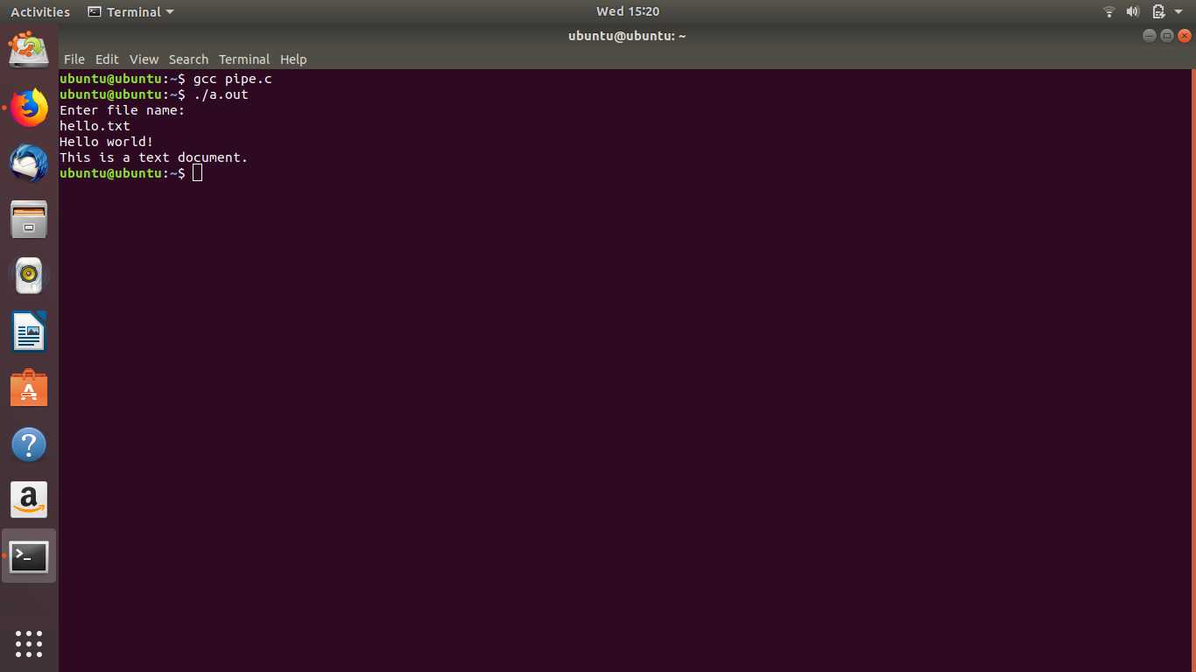

**Part B:  
Code 1 (Read):**

#include <string.h>

#include <fcntl.h>

#include <sys/stat.h>

#include <sys/types.h>

#include<unistd.h>

#include<stdio.h>

int main()

{

char *myfifo="/home/itexam/myfifo";

int fd;

char str[30];

fd=open(myfifo,O_RDONLY);

if(fd==-1)

{

printf("Error.");

}

read(fd,str,sizeof(str));

printf("%s\n",str);

close(fd);

return 0;

}

**Code 2 (Write):**

#include <string.h>

#include <fcntl.h>

#include <sys/stat.h>

#include <sys/types.h>

#include<unistd.h>

#include<stdio.h>

int main()

{

char *myfifo="/home/itexam/myfifo";

int fd;

mkfifo(myfifo,0666);

fd=open(myfifo,O_WRONLY);

if(fd==-1)

{

printf("Error.");

}

write(fd,"Hello",5);

close(fd);

return 0;

}

**Output:**

